Semi-Regular Periodic Tessellation
# Source: AI Source: Provided by: [Data Path: Persons Table -> ID Column: 1, Name_En Column: Motasem Essam] -> From: [ChatGPT] on [7/25/2026]
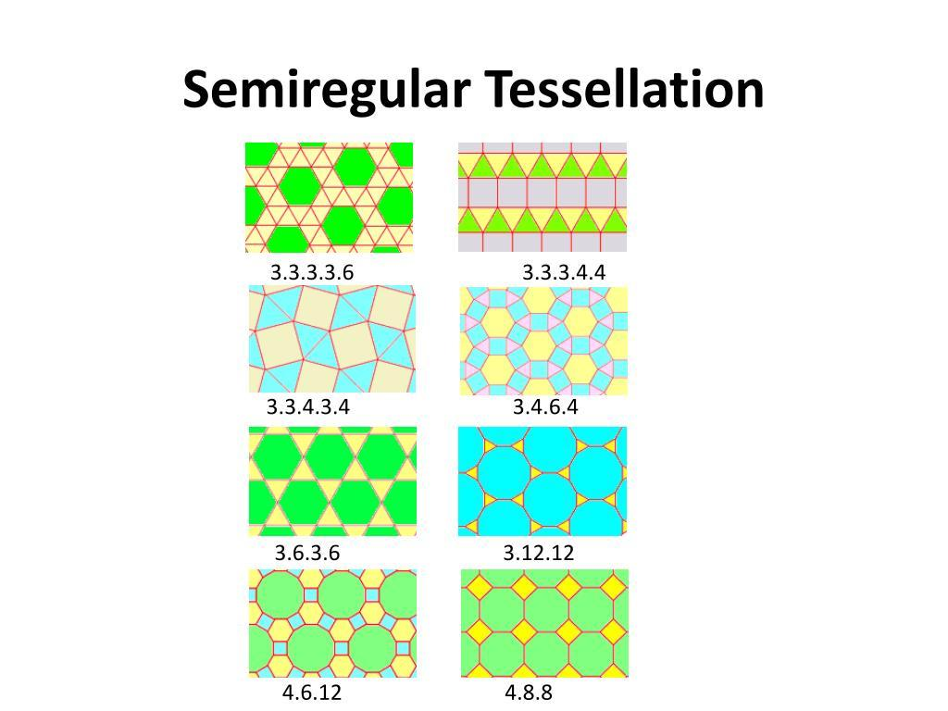
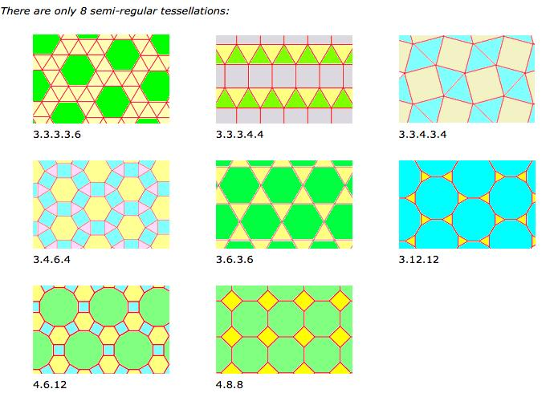
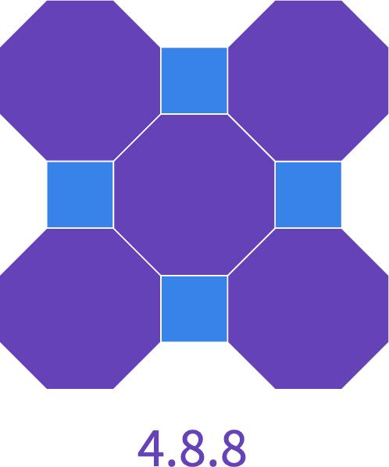
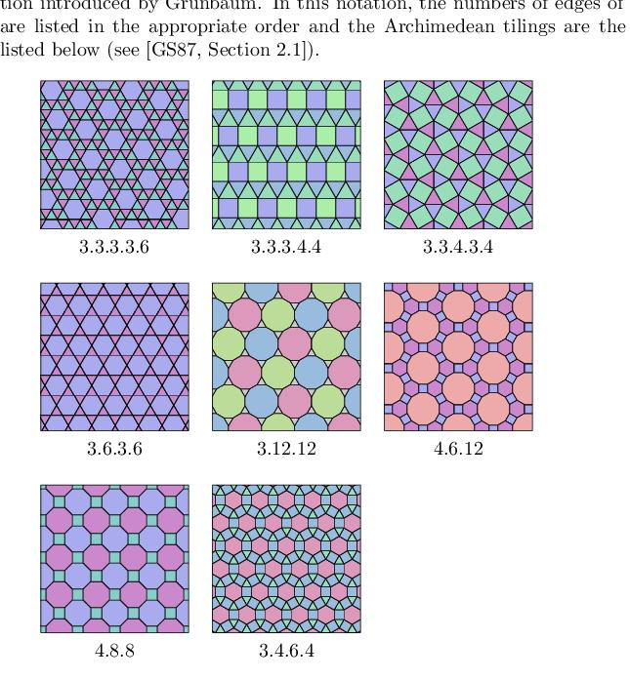

Definition
# Source: AI Source: Provided by: [Data Path: Persons Table -> ID Column: 1, Name_En Column: Motasem Essam] -> From: [ChatGPT] on [7/25/2026]
A Semi-Regular Periodic Tessellation is a tessellation of the Euclidean plane that:
- Uses two or more types of regular polygons.
- Covers the plane completely with no gaps or overlaps.
- Has the same cyclic arrangement of polygons around every vertex.
- Has a repeating translational pattern, so a nonzero translation can map the tessellation onto itself.
This is the standard mathematical notion of a semi-regular tessellation, also called an Archimedean tessellation. There are exactly 8 mixed semi-regular tessellations in the Euclidean plane. (MathWorld)

Classification Position
# Source: AI Source: Provided by: [Data Path: Persons Table -> ID Column: 1, Name_En Column: Motasem Essam] -> From: [ChatGPT] on [7/25/2026]
Your classification can be represented as:
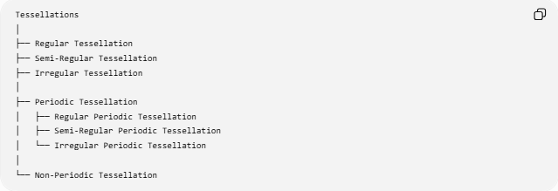
Tessellations
│
├── Regular Tessellation
├── Semi-Regular Tessellation
├── Irregular Tessellation
│
├── Periodic Tessellation
│ ├── Regular Periodic Tessellation
│ ├── Semi-Regular Periodic Tessellation
│ └── Irregular Periodic Tessellation
│
└── Non-Periodic Tessellation
Important: these are two different classification dimensions.
- Regular / Semi-Regular / Irregular describes the geometric structure of the tiles and vertices.
- Periodic / Non-Periodic describes whether the entire pattern repeats by translation.
Therefore, a semi-regular tessellation is normally also periodic, giving the category Semi-Regular Periodic Tessellation.

Fundamental Characteristics

1. Regular polygons
# Source: AI Source: Provided by: [Data Path: Persons Table -> ID Column: 1, Name_En Column: Motasem Essam] -> From: [ChatGPT] on [7/25/2026]
Only regular polygons are used.
Examples include:
- Equilateral triangles
- Squares
- Regular hexagons
- Regular octagons
- Regular dodecagons

2. More than one polygon type
# Source: AI Source: Provided by: [Data Path: Persons Table -> ID Column: 1, Name_En Column: Motasem Essam] -> From: [ChatGPT] on [7/25/2026]
Unlike a regular tessellation, a semi-regular tessellation uses at least two different polygon types.
For example:
$$3.6.3.6$$
uses:
- triangles $3$
- hexagons $6$

3. Identical vertex configuration
# Source: AI Source: Provided by: [Data Path: Persons Table -> ID Column: 1, Name_En Column: Motasem Essam] -> From: [ChatGPT] on [7/25/2026]
The same sequence of polygons occurs around every vertex, up to rotation or reflection. This is the key property that distinguishes the standard Archimedean/semi-regular tilings. (MathWorld)

4. Angles around every vertex total ${360}^{∘}$
# Source: AI Source: Provided by: [Data Path: Persons Table -> ID Column: 1, Name_En Column: Motasem Essam] -> From: [ChatGPT] on [7/25/2026]
For a valid Euclidean tessellation:
$$\sum{\text{angles around a vertex}}={360}^{∘}$$
For example, in $3.6.3.6$:
$${60}^{∘}+{120}^{∘}+{60}^{∘}+{120}^{∘}={360}^{∘}$$

5. Periodicity
# Source: AI Source: Provided by: [Data Path: Persons Table -> ID Column: 1, Name_En Column: Motasem Essam] -> From: [ChatGPT] on [7/25/2026]
The pattern repeats through translation. Consequently, a fundamental repeating region can be identified.

The 8 Semi-Regular Periodic Tessellations
# Source: AI Source: Provided by: [Data Path: Persons Table -> ID Column: 1, Name_En Column: Motasem Essam] -> From: [ChatGPT] on [7/25/2026]
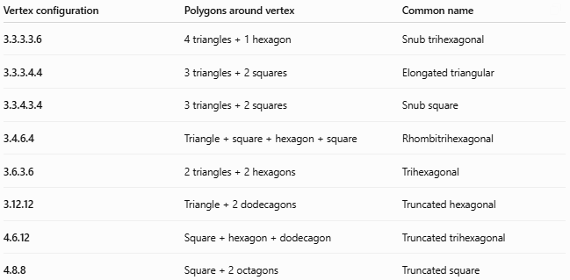
Vertex configuration | Polygons around vertex | Common name
3.3.3.3.6 | 4 triangles + 1 hexagon | Snub trihexagonal
3.3.3.4.4 | 3 triangles + 2 squares | Elongated triangular
3.3.4.3.4 | 3 triangles + 2 squares | Snub square
3.4.6.4 | Triangle + square + hexagon + square | Rhombitrihexagonal
3.6.3.6 | 2 triangles + 2 hexagons | Trihexagonal
3.12.12 | Triangle + 2 dodecagons | Truncated hexagonal
4.6.12 | Square + hexagon + dodecagon | Truncated trihexagonal
4.8.8 | Square + 2 octagons | Truncated square
These are the eight mixed semi-regular/Archimedean tessellations. (MathWorld)

Understanding the Vertex Notation
# Source: AI Source: Provided by: [Data Path: Persons Table -> ID Column: 1, Name_En Column: Motasem Essam] -> From: [ChatGPT] on [7/25/2026]
The notation tells you the number of sides of each polygon encountered while going around a vertex.
For example:
$$3.4.6.4$$
means:
triangle → square → hexagon → square
around every vertex.
Their interior angles are:
- Triangle = ${60}^{∘}$
- Square = ${90}^{∘}$
- Hexagon = ${120}^{∘}$
- Square = ${90}^{∘}$
Therefore:
$${60}^{∘}+{90}^{∘}+{120}^{∘}+{90}^{∘}={360}^{∘}$$
So the polygons fit perfectly around every vertex.

Example: $4.8.8$
# Source: AI Source: Provided by: [Data Path: Persons Table -> ID Column: 1, Name_En Column: Motasem Essam] -> From: [ChatGPT] on [7/25/2026]
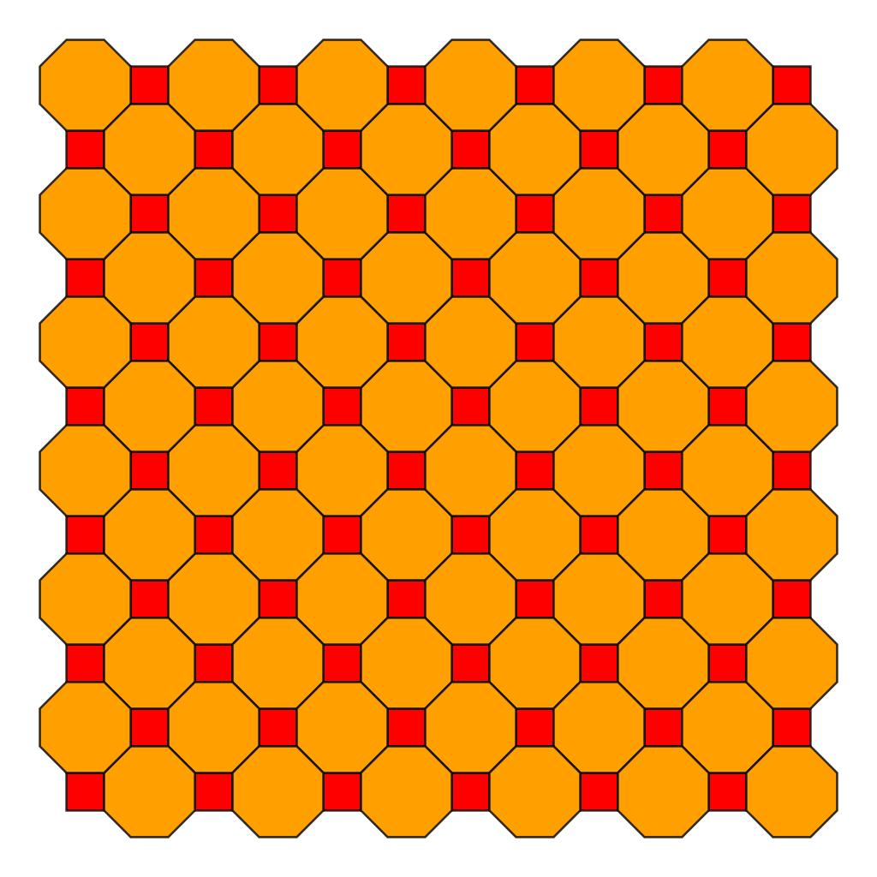
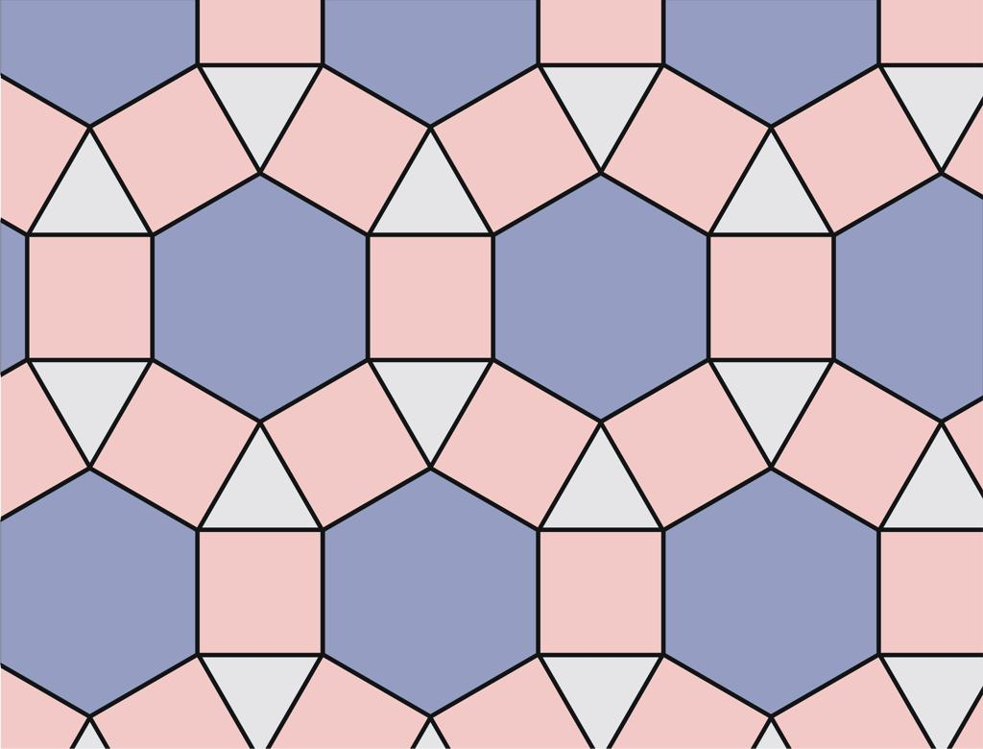
At every vertex:
$$4.8.8$$
means:
square → octagon → octagon
The angles are:
$${90}^{∘}+{135}^{∘}+{135}^{∘}={360}^{∘}$$
Thus the pattern fills the plane without gaps.
It is:
- Semi-regular
- Periodic
- Edge-to-edge
- Composed of regular polygons
- Uniform at its vertices

Example: $3.6.3.6$
# Source: AI Source: Provided by: [Data Path: Persons Table -> ID Column: 1, Name_En Column: Motasem Essam] -> From: [ChatGPT] on [7/25/2026]
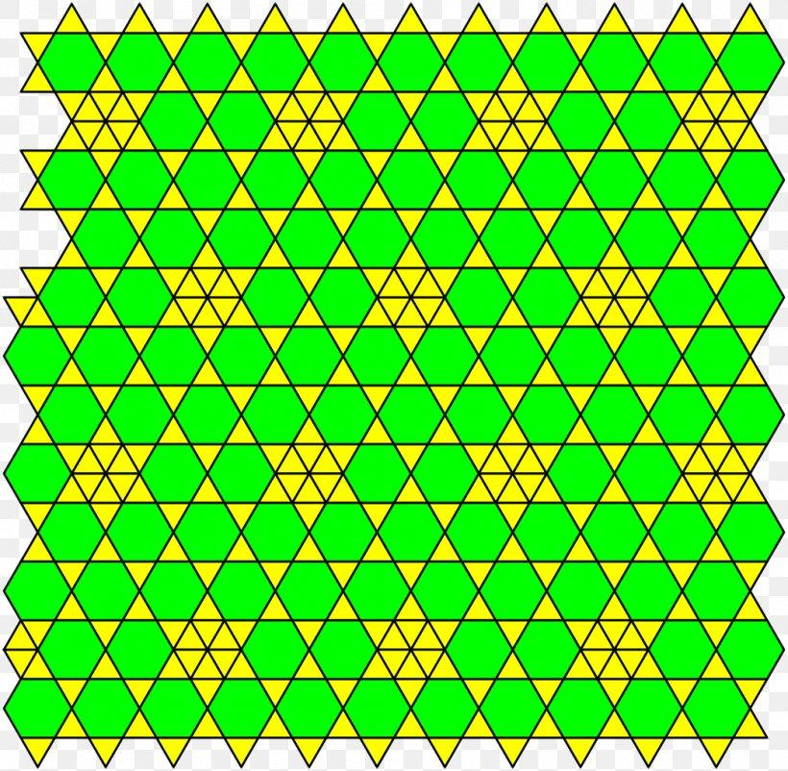
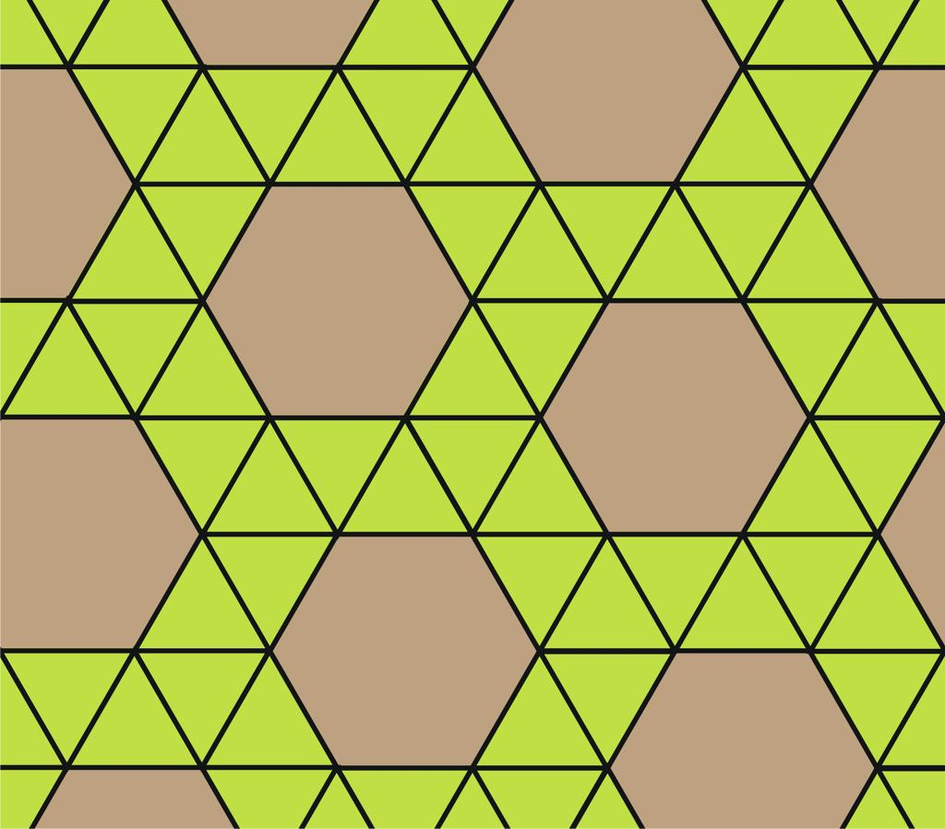
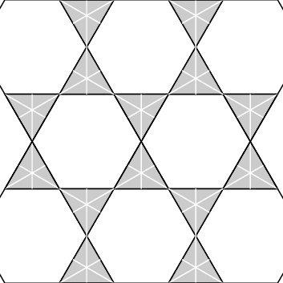
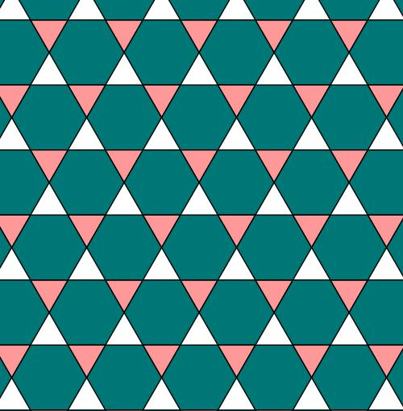
Each vertex contains:
$$3.6.3.6$$
or:
triangle → hexagon → triangle → hexagon
The angles are:
$${60}^{∘}+{120}^{∘}+{60}^{∘}+{120}^{∘}={360}^{∘}$$
It therefore produces a repeating periodic pattern of triangles and hexagons.

Semi-Regular Periodic vs Regular Periodic
# Source: AI Source: Provided by: [Data Path: Persons Table -> ID Column: 1, Name_En Column: Motasem Essam] -> From: [ChatGPT] on [7/25/2026]
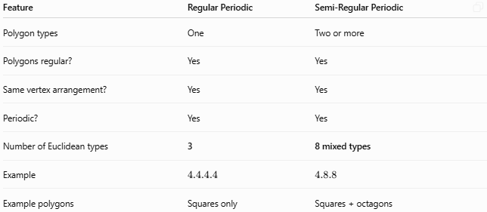
Feature | Regular Periodic | Semi-Regular Periodic
Polygon types | One | Two or more
Polygons regular? | Yes | Yes
Same vertex arrangement? | Yes | Yes
Periodic? | Yes | Yes
Number of Euclidean types | 3 | 8 mixed types
Example | $$4.4.4.4$$ | $$4.8.8$$
Example polygons | Squares only | Squares + octagons
The three regular tessellations are $3.3.3.3.3.3$, $4.4.4.4$, and $6.6.6$, while there are eight mixed semi-regular tessellations. (MathWorld)

Semi-Regular Periodic vs Irregular Periodic
# Source: AI Source: Provided by: [Data Path: Persons Table -> ID Column: 1, Name_En Column: Motasem Essam] -> From: [ChatGPT] on [7/25/2026]
This distinction is especially important for your classification.
Semi-Regular Periodic
- Regular polygons
- Multiple polygon types
- Same vertex configuration everywhere
- Repeating pattern
Example:
$$4.6.12$$
Irregular Periodic
- At least some tiles or arrangements are irregular
- Pattern can still repeat periodically
- Does not require the same Archimedean vertex configuration
Therefore:
Irregular does not mean non-periodic.
An irregular tessellation can still be periodic.

Key Properties
# Source: AI Source: Provided by: [Data Path: Persons Table -> ID Column: 1, Name_En Column: Motasem Essam] -> From: [ChatGPT] on [7/25/2026]
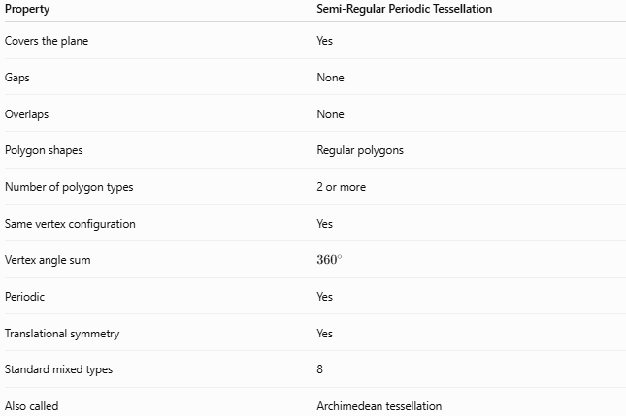
Property | Semi-Regular Periodic Tessellation
Covers the plane | Yes
Gaps | None
Overlaps | None
Polygon shapes | Regular polygons
Number of polygon types | 2 or more
Same vertex configuration | Yes
Vertex angle sum | $${360}^{∘}$$
Periodic | Yes
Translational symmetry | Yes
Standard mixed types | 8
Also called | Archimedean tessellation

Conclusion
# Source: AI Source: Provided by: [Data Path: Persons Table -> ID Column: 1, Name_En Column: Motasem Essam] -> From: [ChatGPT] on [7/25/2026]
A Semi-Regular Periodic Tessellation is a periodic plane tessellation made from two or more types of regular polygons, arranged so that the same sequence of polygons occurs around every vertex.
The eight standard mixed examples are:
$$\boxed{3.3.3.3.6, 3.3.3.4.4, 3.3.4.3.4, 3.4.6.4, 3.6.3.6, 3.12.12, 4.6.12, 4.8.8}$$
These are the 8 mixed Archimedean/semi-regular tessellations of the Euclidean plane. (MathWorld)

